**TravelBooking-3hours.zip**

* Create Bus, Plane, Train booking.
* Traveler can see booking history.
* Staff member can see customer’s booking.
* Unit test project.

**TravelBooking-AllFeatures.zip**

* Save Bus, Plane, Train booking.
* Traveler can see booking history.
* Traveler can see booking xml on booking save.
* *\*Staff member can see customer’s booking.\**
* *\*Staff member can filter customer’s booking.\**
* *\*Staff member can backup xml file in .zip\**
* *\*Some unit testing\**

**Screens and workflows:**

1) First window

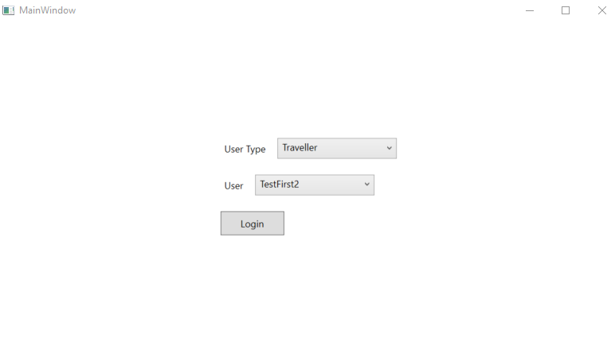

2) Bus Booking

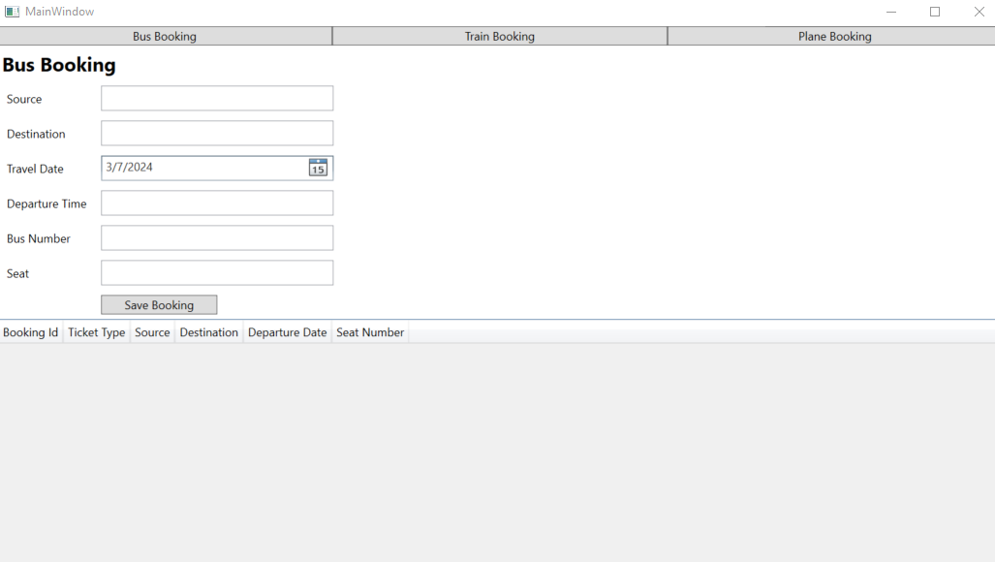

3) Save Bus Booking

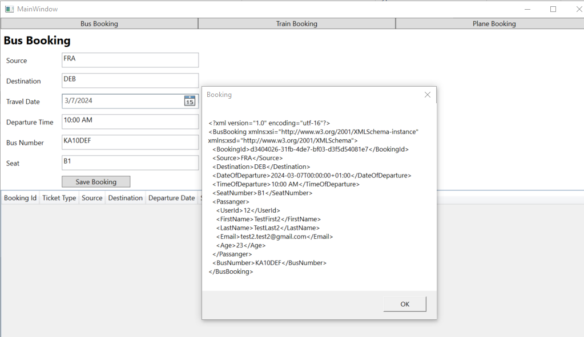

4) Bus booking History

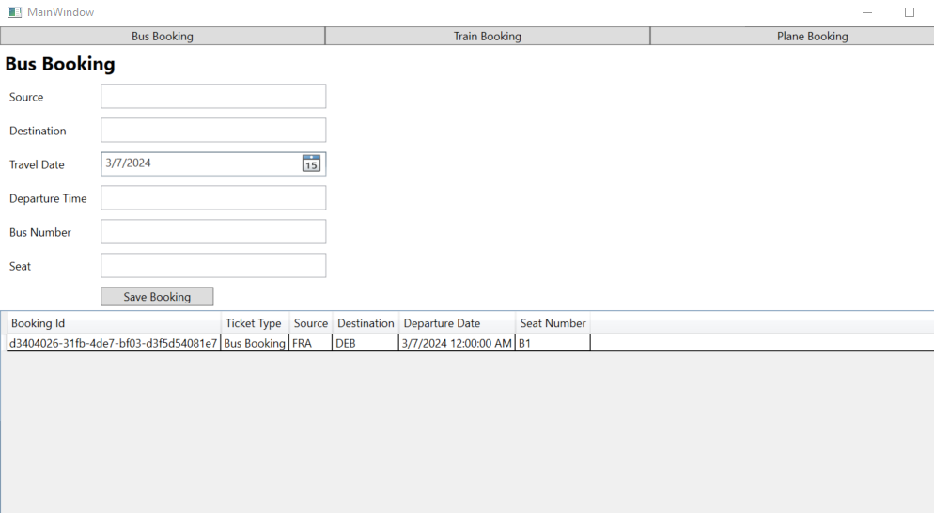

5) Train Booking, Plane Booking

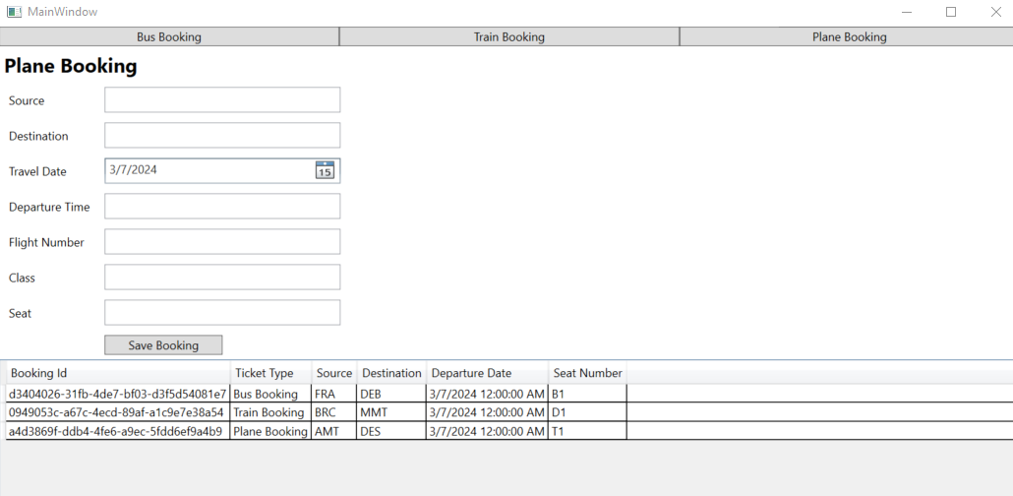

6) Staff member

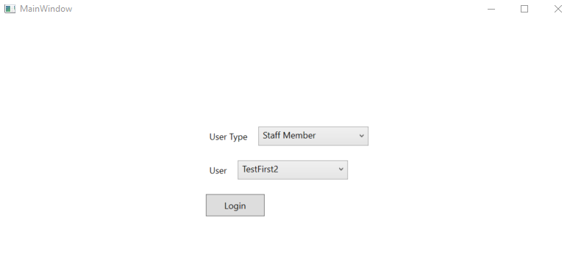

7) Search customer booking

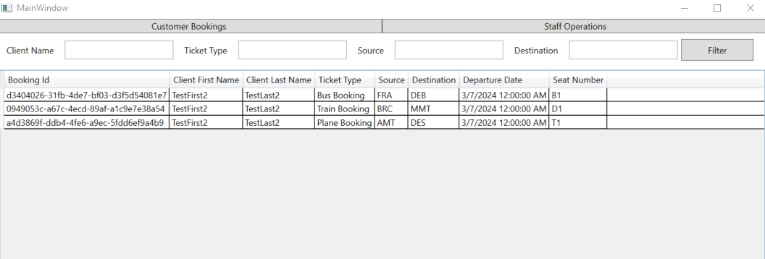

8) Backup

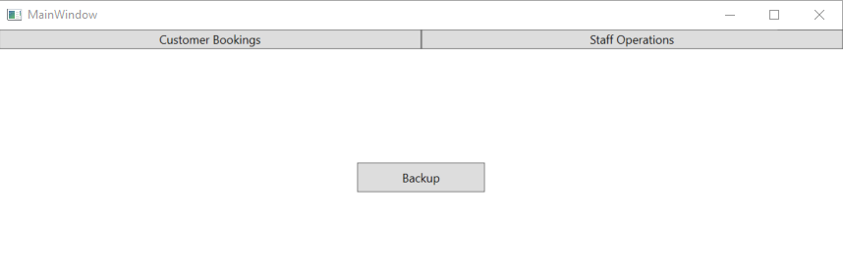

9) Xml & zip file locations

